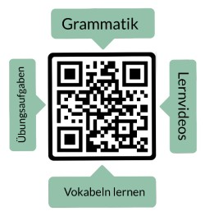**Nombre: ______________________**

**Traduce la palabra alemana al español.**

**Vokabeltest: El tiempo libre**

|  |  |  |
| --- | --- | --- |
| **alemán** | **español** | **puntos** |
| **die Freizeit** |  | 1 |
| **das Hobby** |  | 1 |
| **der Sport** |  | 1 |
| **das Spiel** |  | 1 |
| **das Kino** |  | 1 |
| **feiern** |  | 1 |
| **rennen** |  | 1 |
| **relaxen** |  | 1 |
| **der Park** |  | 1 |
| **das Schwimmbad** |  | 1 |
| **die Disco** |  | 1 |
| **das Restaurant** |  | 1 |

puntos: _____ / 12

nota: ________________________

firma: ________________________

|  |  |  |  |  |  |
| --- | --- | --- | --- | --- | --- |
| sehr gut | gut | befriedigend | ausreichend | mangelhaft | ungenügend |
| 12-11,5 | 11-10 | 9,5-8 | 7,5-6 | 5,5-3 | 2,5-0 |